**Assignment 5.3:**

Implement the use case present in below blog link and share the complete steps along with

screenshot(s) from your end.

NOTE: You must submit a word file containing steps and screenshots.

**Load_Data = LOAD ‘/home/acadgild/pig/Pokemon.csv’ USING PigStorage(‘,’) AS(Sno:int,Name:chararray,Type1:chararray,Type2:chararray,Total:int,HP:int,Attack:int,Defense:int,SpAtk:int,SpDef:int,Speed:int);**

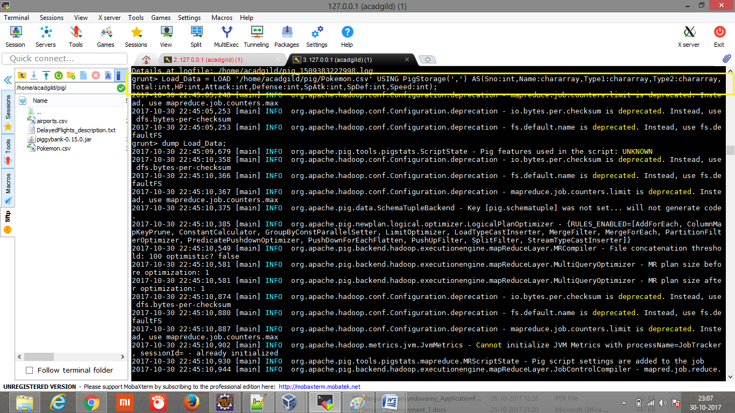

Dump Load_Data;

Shown only few data (as per screen height)

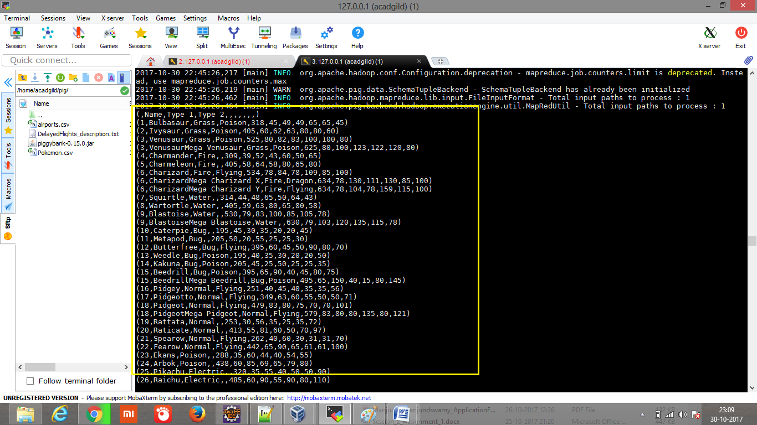

**Ques 1: Find the list of players that have been selected in the qualifying round (DEFENCE>55).**

#### Explanation:

**Command**

**selected_list = FILTER Load_Data BY Defense>55;**

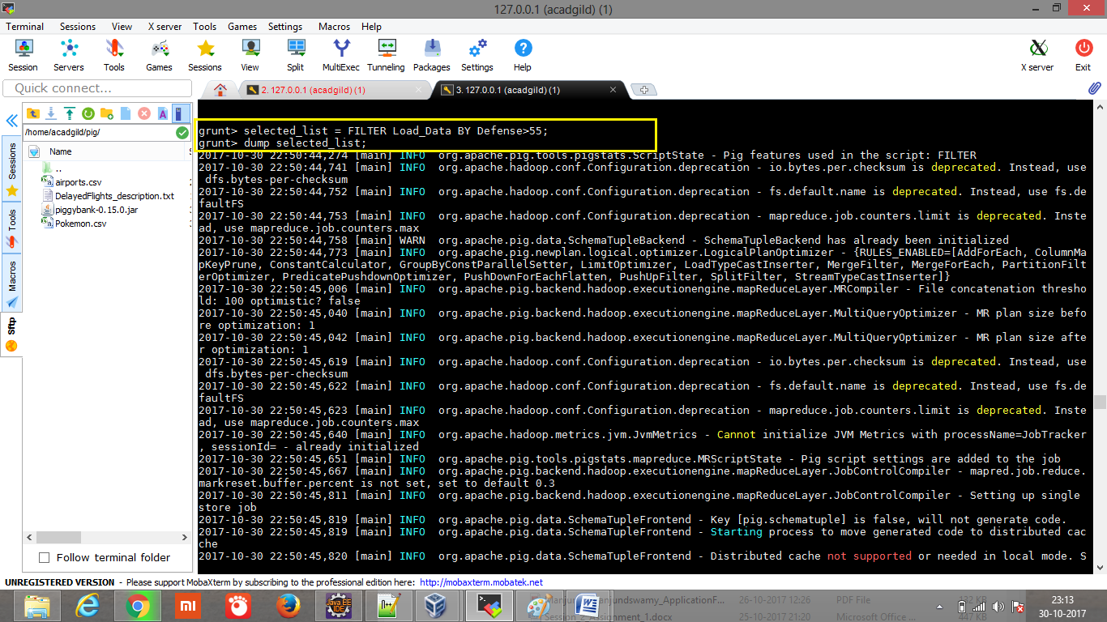

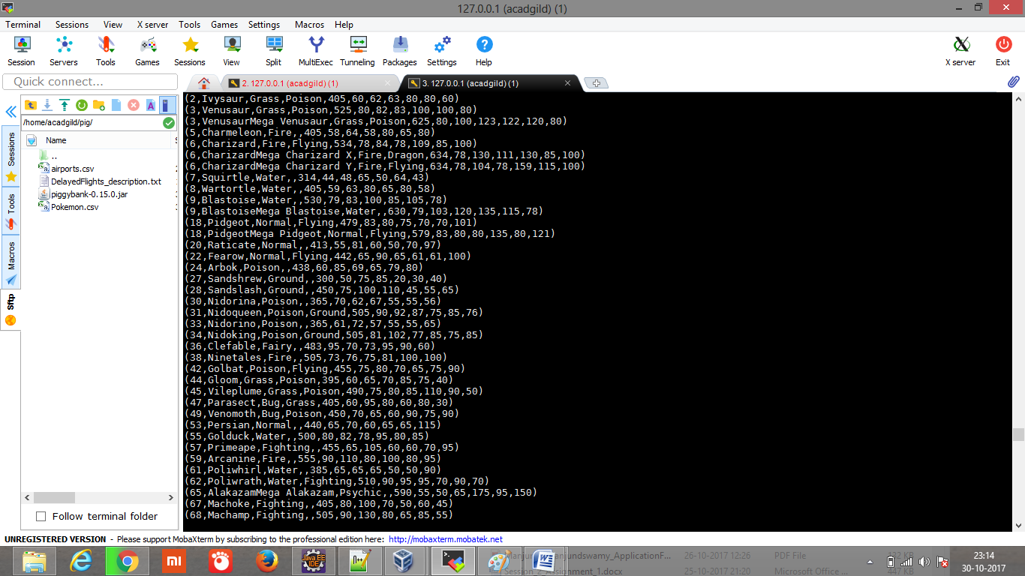

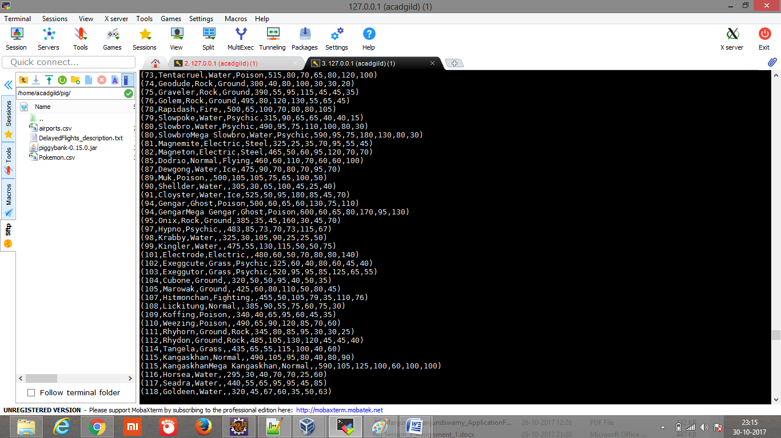

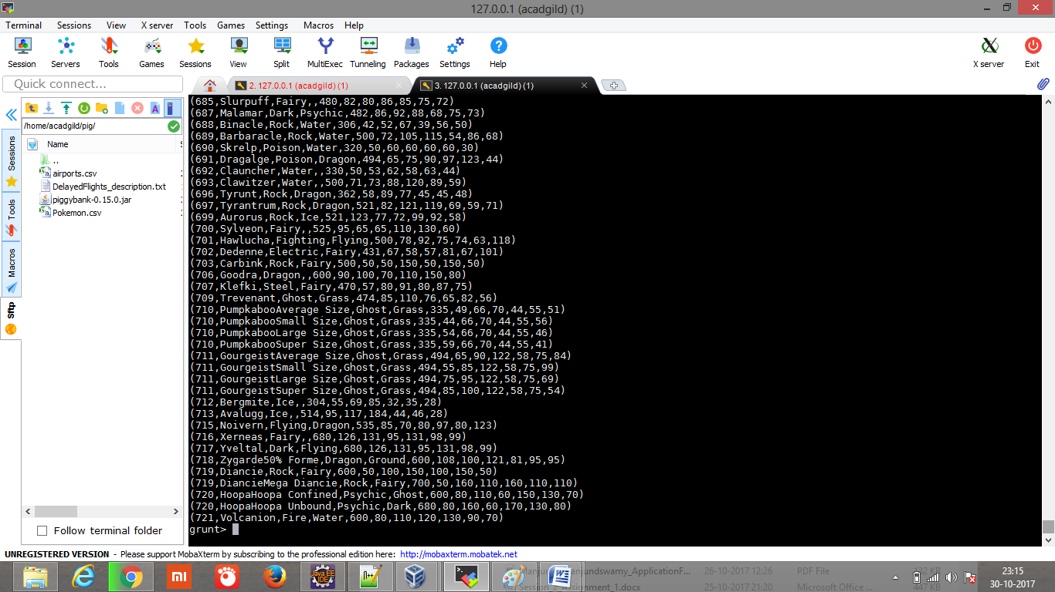

#### Ques 2: State the number of players taking part in the competition after getting selected in the qualifying round.

**Explanation:**

**Command:**

**gourp_selcted_list = Group selected_list All;**

**count_selcted_list = foreach gourp_selcted_list GENERATE COUNT(selected_list);**

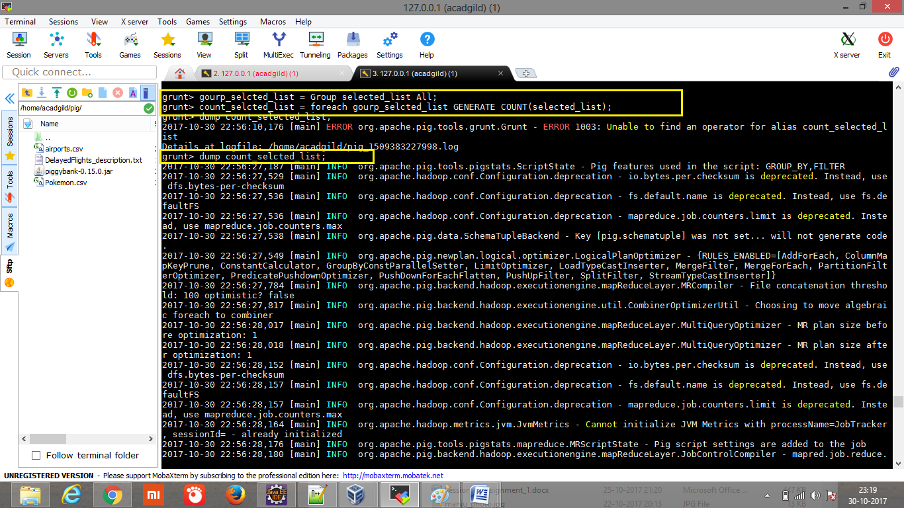

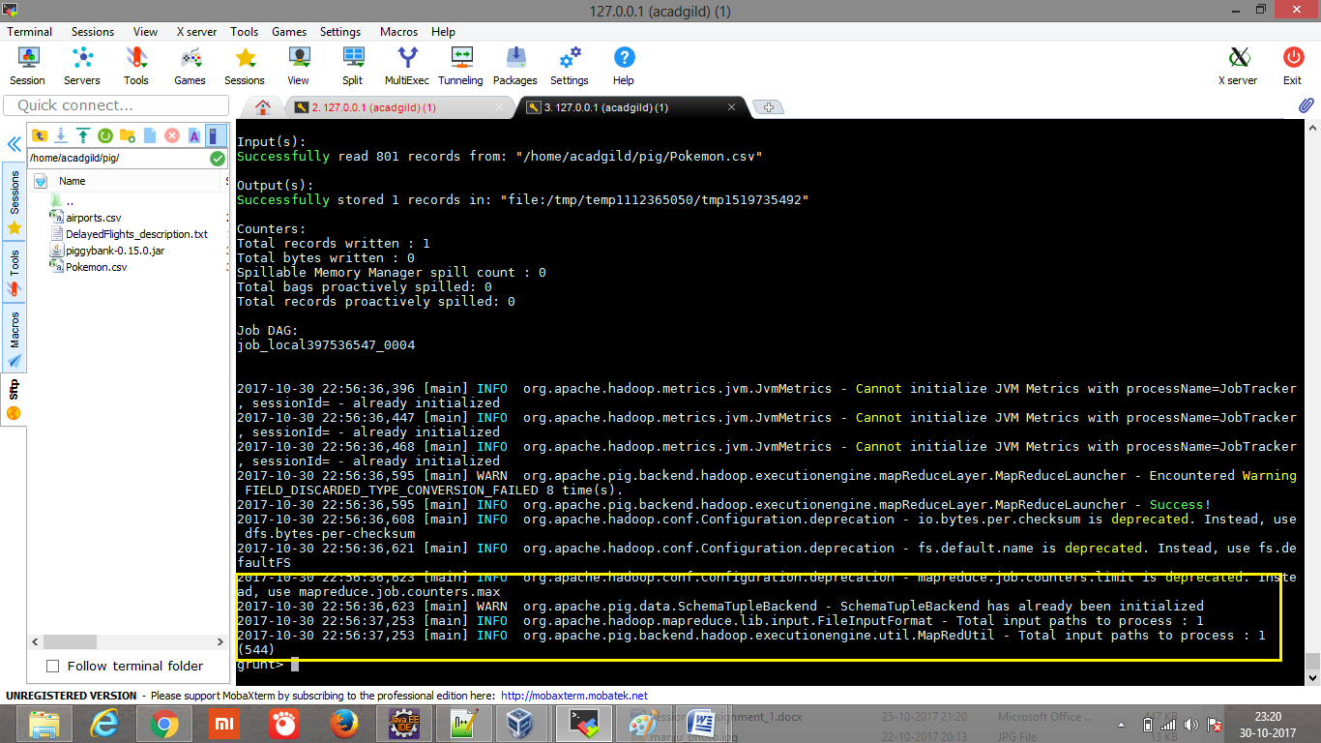

**Ques 3: Using random() generate random numbers for each Pokémon on the selected list.**

**Explanation:**

***Command***

**random_include1 = foreach selected_list GENERATE RANDOM(),Name,Type1,Type2,Total,HP,Attack,Defense,SpAtk,SpDef,Speed;**

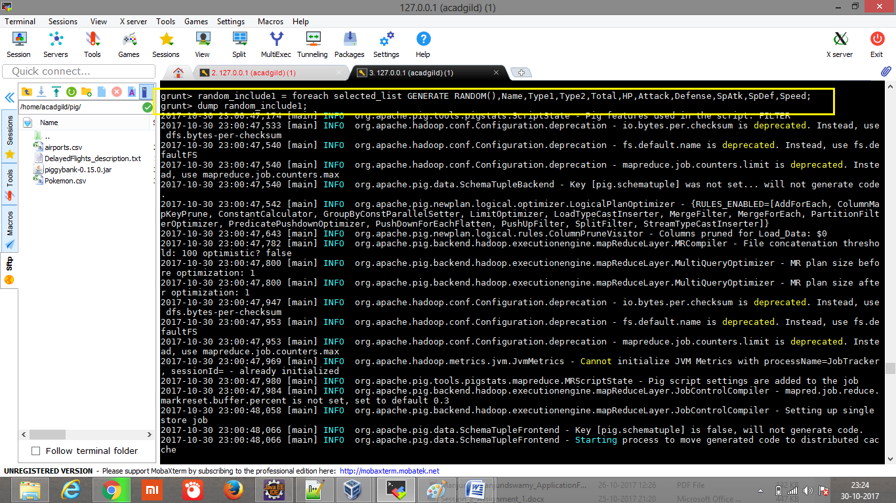

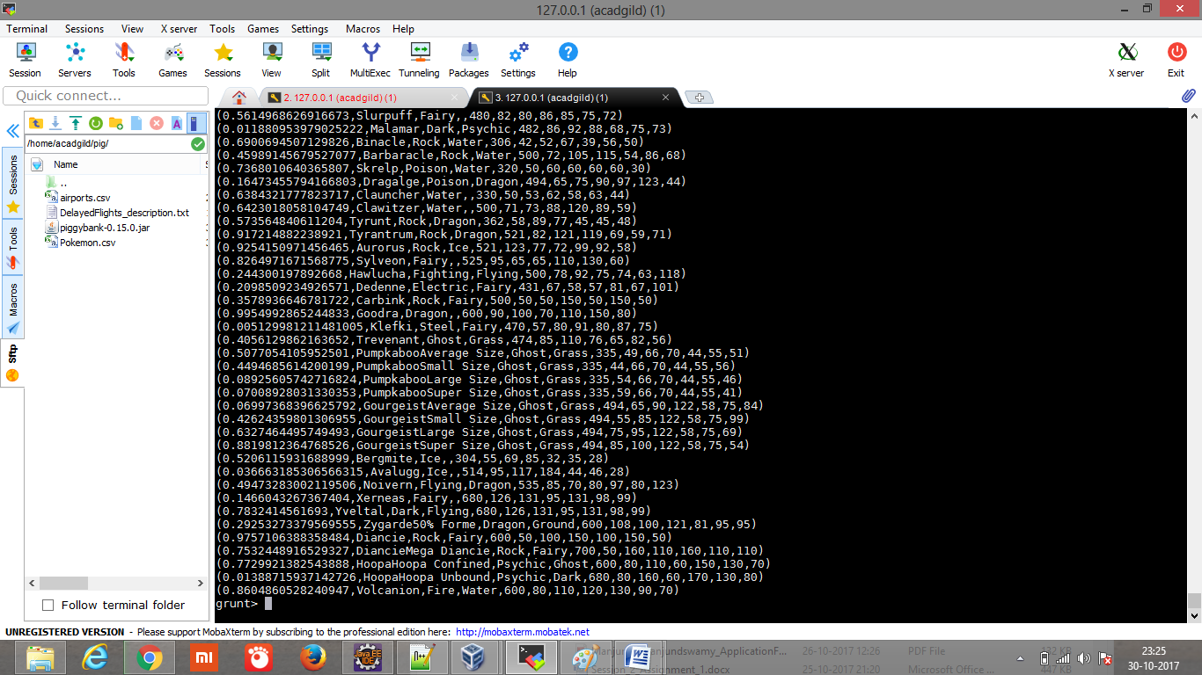

**Ques 4: Arrange the new list in a descending order according to a column randomly.**

**Explanation: This will give us consequently a layer arranged to pick the random list which 1st player will choose.**

***Command***

**random1_desending = ORDER random_include1 BY $0 DESC;**

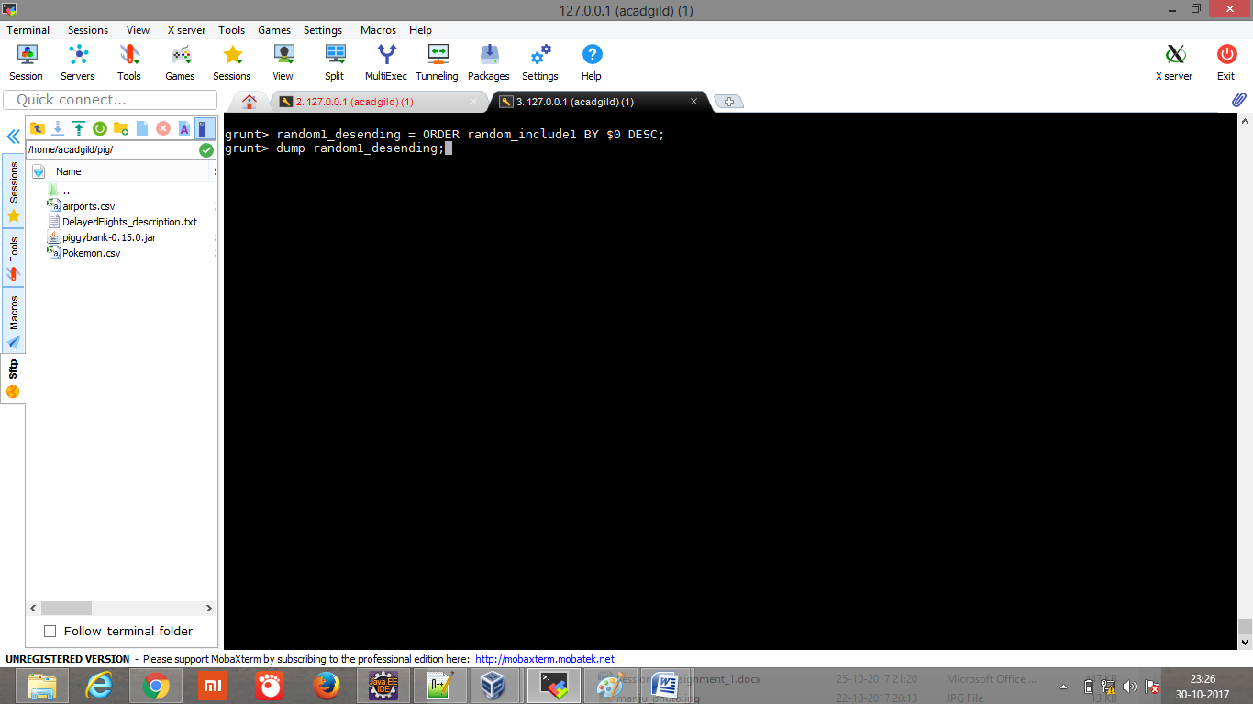

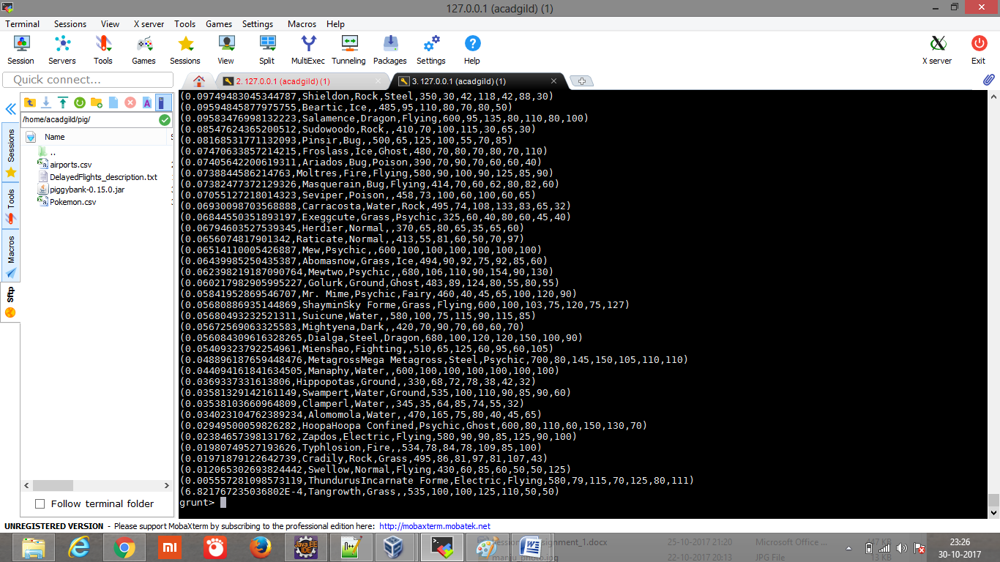

**Ques 5: Now on a new relation again associate random numbers for each Pokémon and arrange in descending order according to column random.**

**Explanation: We will be repeating above two steps again to form the 2nd list.**

***Command***

**random_include2 = foreach selected_list GENERATE RANDOM(),Name,Type1,Type2,Total,HP,Attack,Defense,SpAtk,SpDef,Speed;**

**random2_desending = ORDER random_include2 BY $0 DESC;**

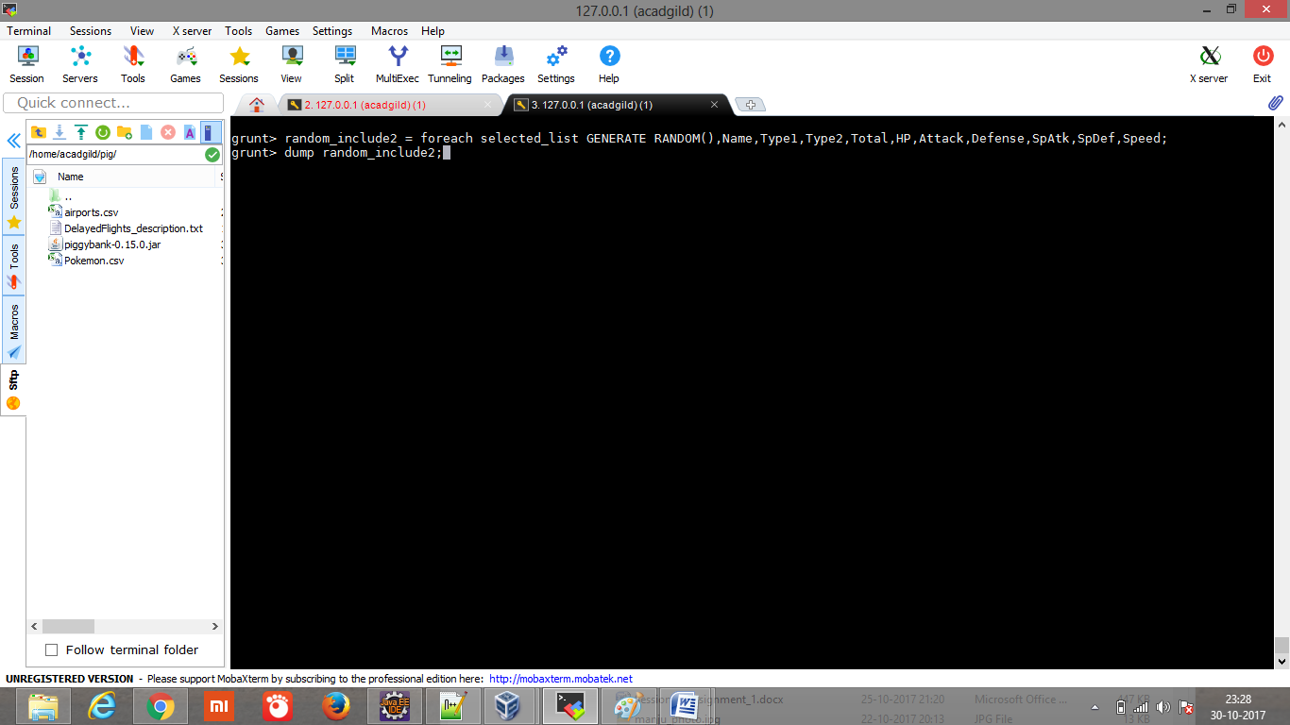

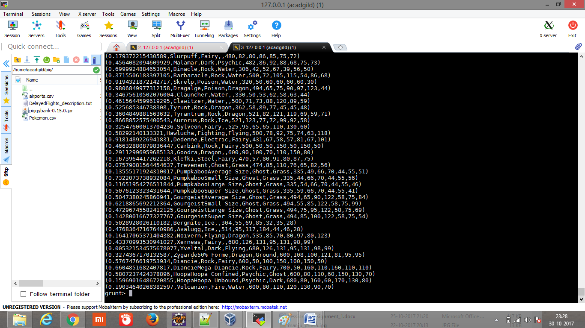

random2_desending = ORDER random_include2 BY $0 DESC;

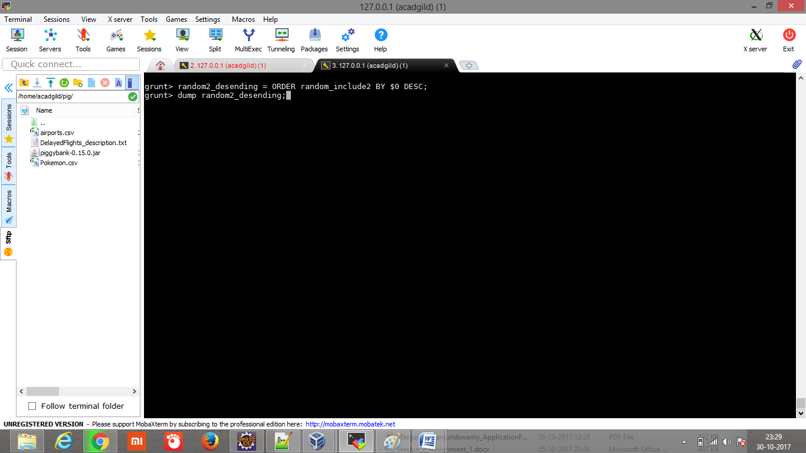

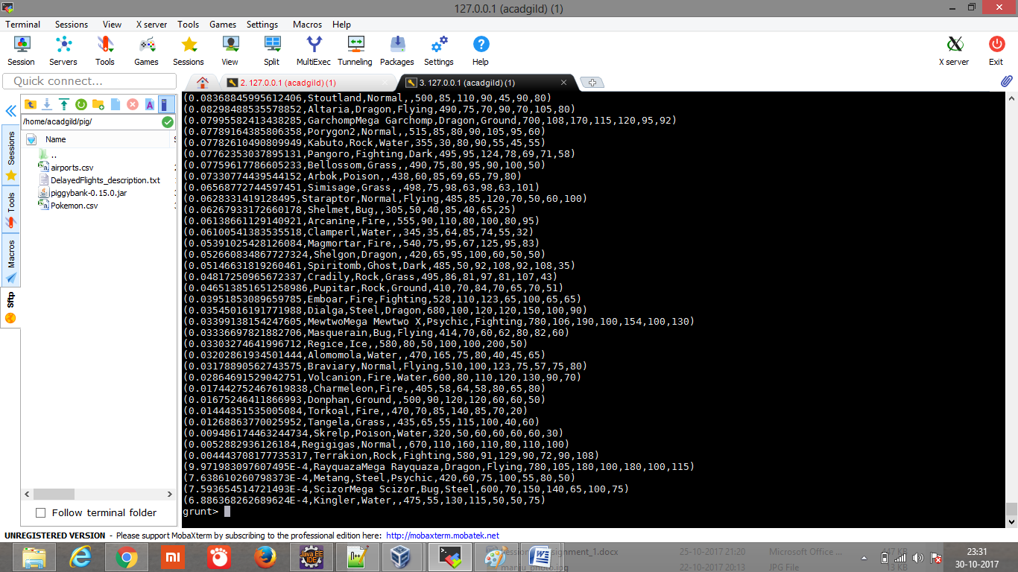

**Ques: From the two different descending lists of random Pokémons, select the top 5 Pokémons for 2 different players.**

**Explanation:**

***Commands***

**limit_data_random1_desending = LIMIT random1_desending 5 ;**

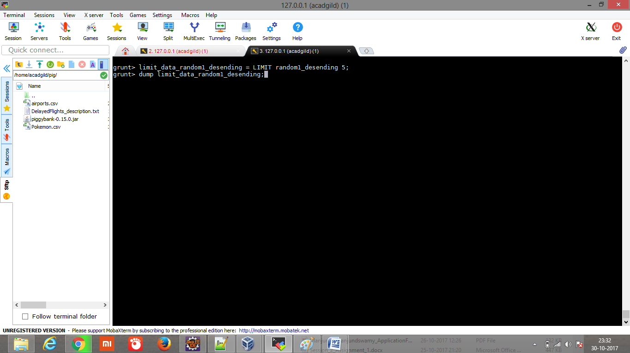

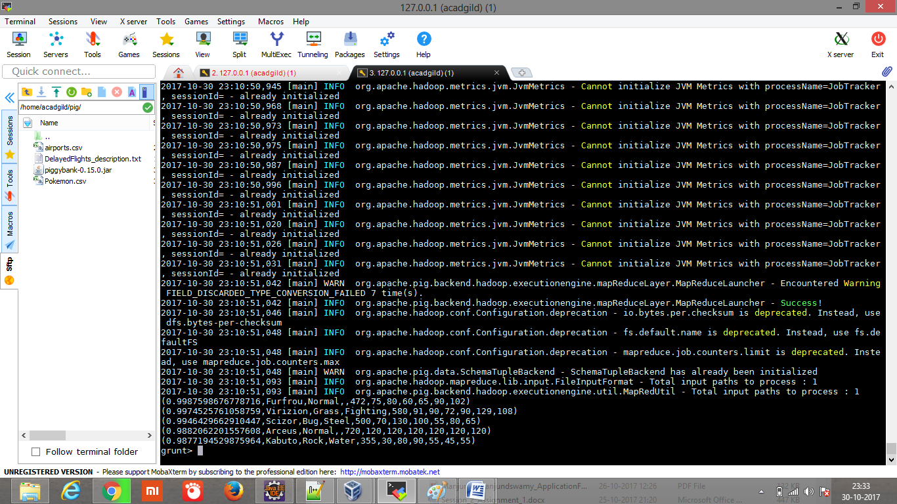

**limit_data_random2_desending = LIMIT random2_desending 5 ;**

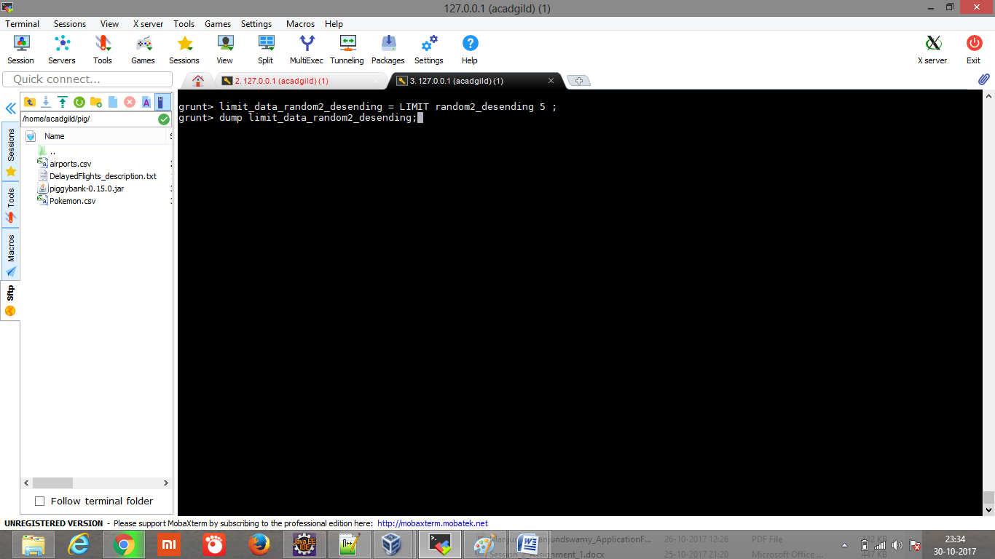

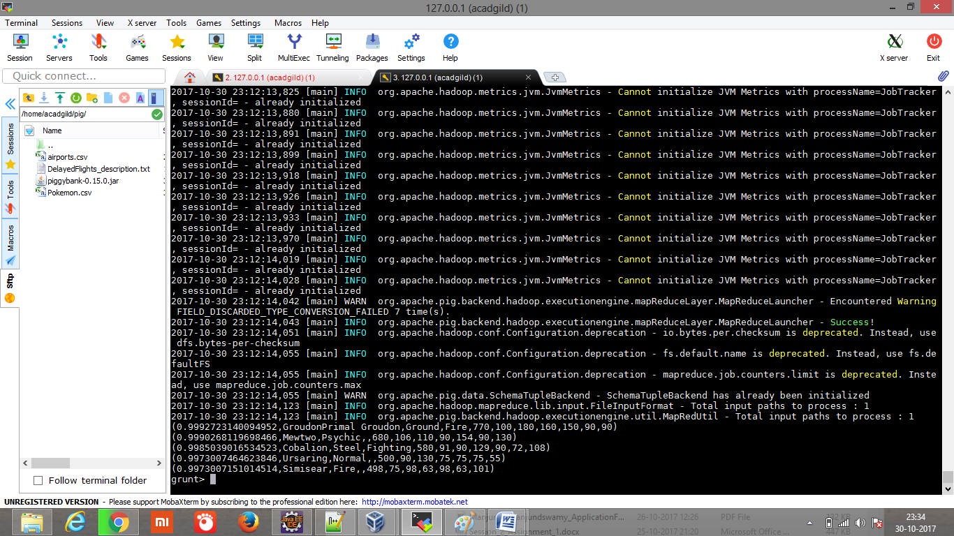

**Ques: Store the data on a local drive to announce for the final match. By the name player1 and player2 (only show the NAME and HP).**

**Explanation:**

***Commands***

**filter_only_name1 = foreach limit_data_random1_desending Generate ($1,HP);**

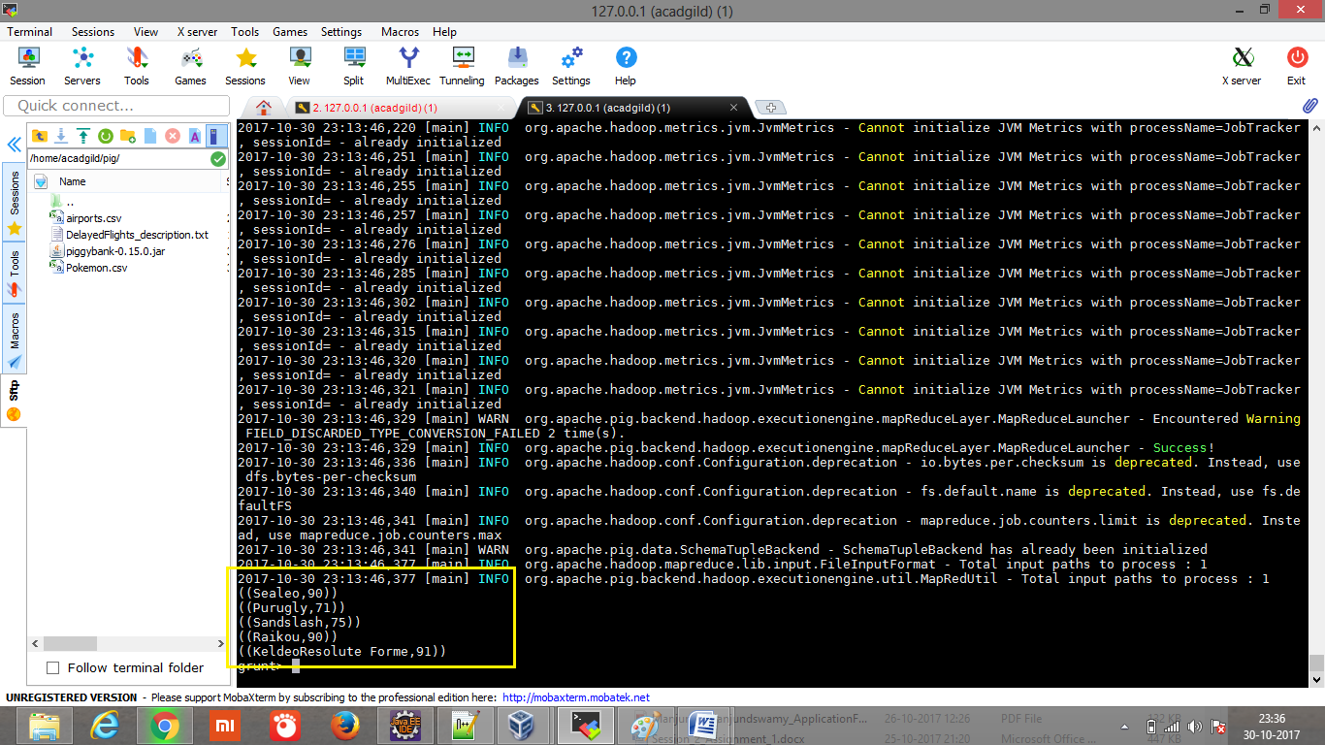

filter_only_name2 = foreach limit_data_random2_desending Generate ($1,HP);

dump filter_only_name2;

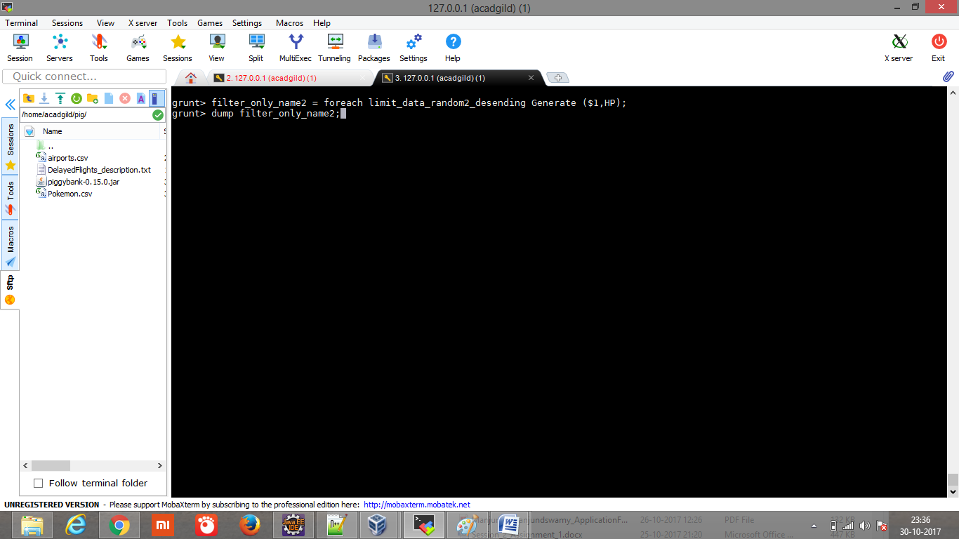

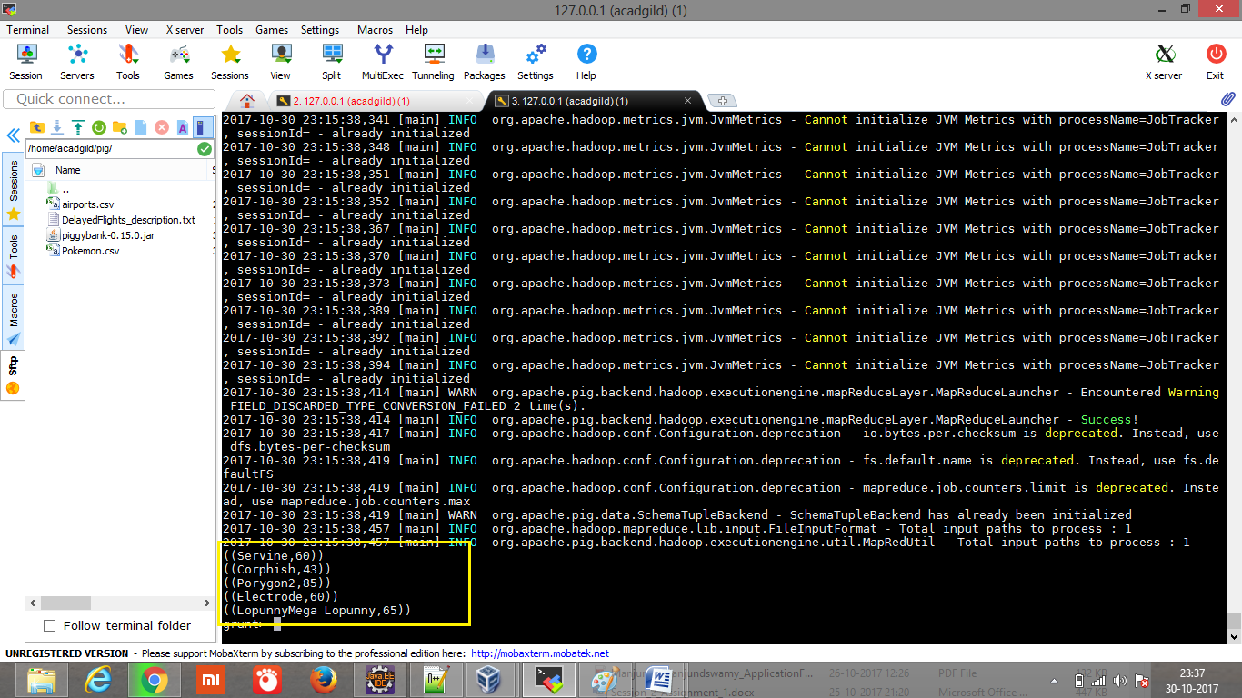

**STORE limit_data_random1_desending INTO ‘/home/acadgild/pig/player1.txt’;**

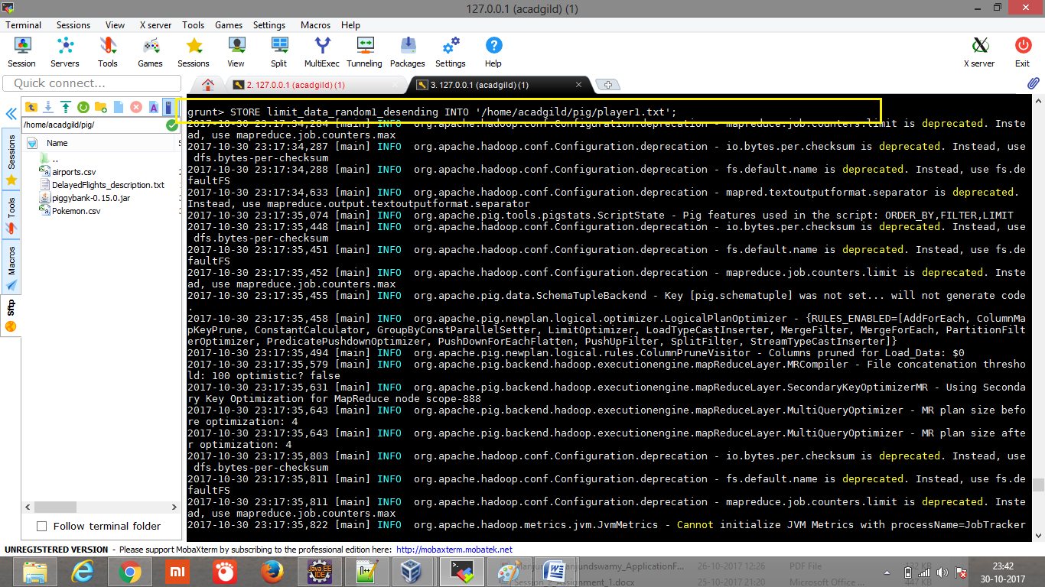

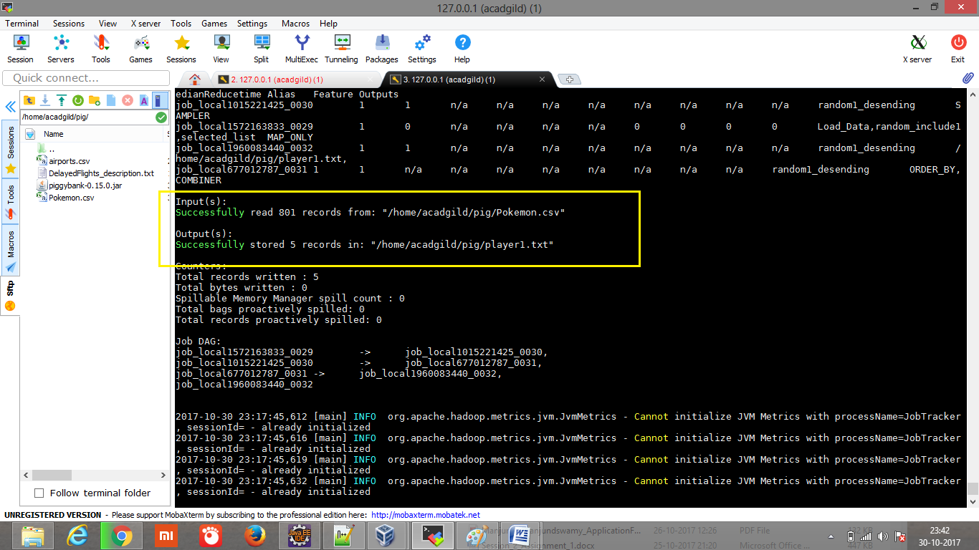

STORE limit_data_random2_desending INTO ‘/home/acadgild/pig/player2.txt’;

